The Poor at Your Gates
June 20th, 2020
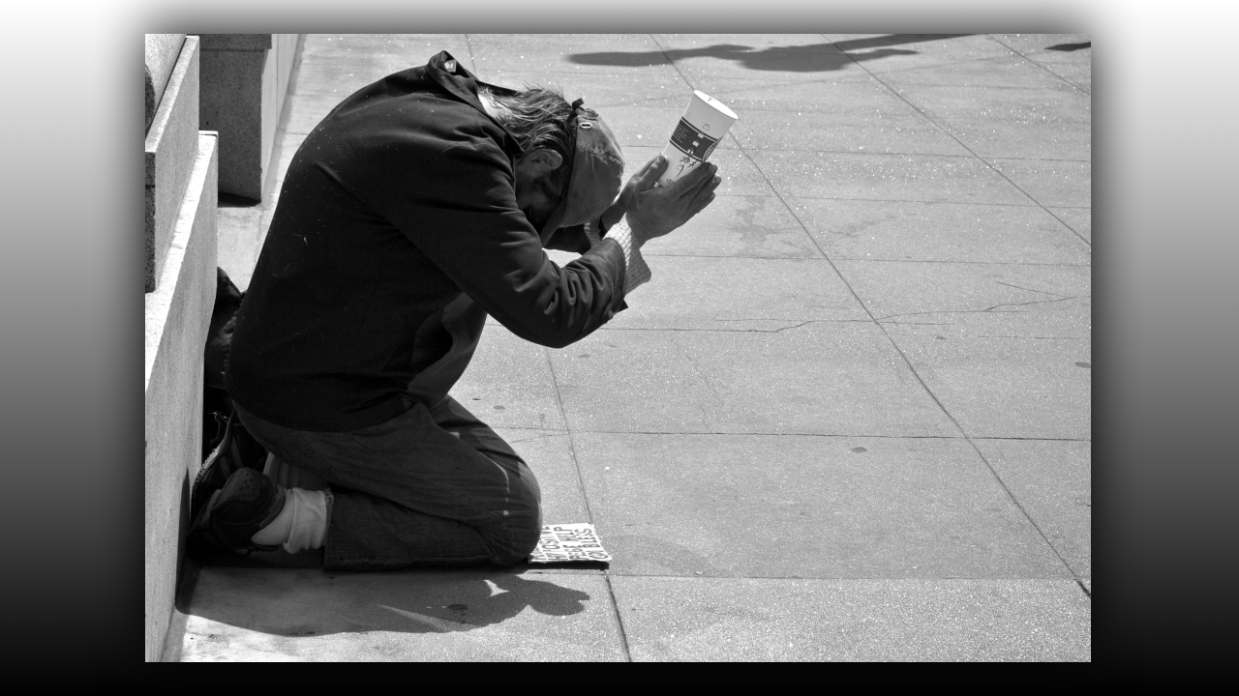
May the Lord soften our hearts and may we feel the same way He feels about our brothers and sisters who are poor. You know the Lord is very concerned in this moment for His people, because there are many living for themselves. They are Christians by name but their actions don’t convict them. The very night I was receiving the message from the Lord about repentance and the Rapture just a couple of days ago, that very night Ezekiel was in his room receiving this message. You know that I do not speak harshly, for the most part, but this is urgent and it is what was given to Ezekiel. This message may not apply to the majority of you, however, for the ones it does apply to, it must be given.
No man knows the hour, the day or even the year. But we all know the Rapture could happen at any time. Jesus is concerned because there are many who are living for themselves and avoiding the poor, like a dirty rag. I know this feeling well. I used to be one of these and could backslide overnight if the Lord did not keep a good hold on my heart.
I remember getting dressed for Sunday morning church was like preparing for a fashion show. I remember also, avoiding those who came to church in dumpy clothes, I remember the nice restaurant lunches after church, and seeing the poor walking home or struggling to get their car started with four children piled up inside. I was a very vain and shallow Christian and I knew there was something not right about my heart. Then one day the Lord opened my eyes and my heart to the poor.
I loved sitting in the front of the Sunday School class while the lame and poor sat in the back. There came a time when I began to feel compunction, and I wanted to sit with them. I began to dislike my dressed-up self and all I wanted was to be free and sit with the poor. This undoubtedly was a grace. Not long after that I left the upper-class Washington DC church and became a Franciscan sister. I fell in love with the example St. Francis set as he followed in the footsteps of Christ and St. Paul and the early apostles. I could feel the self-righteousness I had and it made me sick at heart, I hungered for that humility and evangelical poverty, that Jesus lived with the first disciples. So now we are living a life similar to that in our tiny community up here in the mountains, doing all we can to alleviate the suffering of the poor among us and the trafficked children around the world.
I am not saying I have arrived, I am saying, I have walked away from the world to follow our Lord, yet there is always room for improvement. For instance, while I was editing this message, a phone call came in from a little one, and I thought, "I will call her back after I finish editing, she can wait." But I believe the Lord was not pleased with that attitude, because when I went back to editing, all of a sudden, the sound wouldn't work. I couldn’t hear a thing. I can't edit without hearing...can I? I felt compunction in my conscience and I stopped what I was doing to call her back immediately. You see, I have a long way to go to reach perfection. So, I offer this message to you in my own fear and trembling, knowing that I could always do more for the Lord who lives in the poor and longs to see His Church taking care of all her needs.
Ezekiel’s message began with the Lord saying:
“Son of Man, write down these words,
How Long, how long will you crush the poor at your gates?
You ask, “Which Poor? What Gates?”
You see them clearly, each and every Sunday. You avoid them at all cost.
These are My Little Ones, that you so blithely escort to the back seats when you assemble. They are the “Un-Beautiful” ones. Those of whom you say,
“Hurry along! Hurry along!” You and your spouses, irritated and brow down, turn to
one another saying, “Oh No! It is them again!”
Meanwhile you shepherds turn your heads down, so as not to see them, while reading
and re-reading the notes of your skillfully composed messages; yet corrupting the truth of My Holy Scriptures, in favor of the wealthy.
Have you not read repeatedly My admonitions for you? The fasting I require is to feed the widow and the orphan, to welcome the stranger into your midst, and not turning your back on your own. Yes, your own, - your own kindred in Me, the least of these Living Stones that were meant to build up as an edifice, My Body. Do you not excuse yourselves saying, “We are here to worship, and to be taught, not to wait on those who should have the good sense to take care of themselves?”
If that were not enough, after the service you quickly slip through the crowd unnoticed, on the way to your clean and freshly waxed car. You intentionally dodge these “ragged” ones who are so simple minded and plain.
How many are they, who long to be invited to your luncheons. You see them walking, now in the heat of the day, counting their few coins to see if they have enough to pay the bus fare. And yet you speed by them on the boulevard being very careful not to make eye contact.
Do you expect to be swept up into the Heavens when I arrive? I tell you solemnly, you will not taste of My banquet, nor will you be caught up in the clouds. Rather, you will stand in utter disbelief, as you watch those lesser ones ascending, to be with Me forevermore.
How many of you will call out to Me, so fearful of what is in prospect for you? Yes, such suffering as has never been seen, and will never be seen again on the earth. Woe unto woe will be added to you, for you have discriminated against the Poor at your gates.”

And that was the end of the Lord’s message to Ezekiel.

I don’t know how that affects you but I know that I have been guilty of that and I don’t ever, ever, ever want to be guilty of it again. Only the Lord can change our hearts dear ones. If you are a part of the beautiful people or the middle-class Christians that don’t have the time of day for the poor. I hate to tell you this but you’re not going with the Lord in the rapture. Remember He said He would separate the sheep from the goats.

In Matthew 25 Jesus said:
31 “When the Son of Man comes in his glory, and all the angels with him, he will sit on his glorious throne. 32 All the nations will be gathered before him, and he will separate the people one from another as a shepherd separates the sheep from the goats. 33 He will put the sheep on his right and the goats on his left.
34 “Then the King will say to those on his right, ‘Come, you who are blessed by my Father; take your inheritance, the kingdom prepared for you since the creation of the world. 35 For I was hungry and you gave me something to eat, I was thirsty and you gave me something to drink, I was a stranger and you invited me in, 36 I needed clothes and you clothed me, I was sick and you looked after me, I was in prison and you came to visit me.’
37 “Then the righteous will answer him, ‘Lord, when did we see you hungry and feed you, or thirsty and give you something to drink? 38 When did we see you a stranger and invite you in, or needing clothes and clothe you? 39 When did we see you sick or in prison and go to visit you?’
40 “The King will reply, ‘Truly I tell you, whatever you did for one of the least of these brothers and sisters of mine, you did for me.’
41 “Then he will say to those on his left, ‘Depart from me, you who are cursed, into the eternal fire prepared for the devil and his angels. 42 For I was hungry and you gave me nothing to eat, I was thirsty and you gave me nothing to drink, 43 I was a stranger and you did not invite me in, I needed clothes and you did not clothe me, I was sick and in prison and you did not look after me.’
44 “They also will answer, ‘Lord, when did we see you hungry or thirsty or a stranger or needing clothes or sick or in prison, and did not help you?’
45 “He will reply, ‘Truly I tell you, whatever you did not do for one of the least of these, you did not do for me.’
46 “Then they will go away to eternal punishment, but the righteous to eternal life.”

And there’s another place in scripture where people answer the Lord and say, “But I preached and I healed in your name and I delivered people in your name” and He will say to them, “I never knew you”. And what is that all about, it’s about knowing the heart of God, knowing His heart and Him knowing you and being of one heart with Jesus. This is what we will be asked about, this is what will be examined in our lives. Did we learn how to love? Did we learn how to give? I can’t remember if it was Oral Roberts or a very, very famous evangelist who had done quite a bit of work for the Lord and he died and went to heaven and Peter was standing at the gates and he asked him, “Did you learn to love?” and that was the only thing he asked him. And he had not learned to love, he learned how to study but he hadn’t learned how to love. So, St. Peter said, “Go back down to earth and learn how to love”. He was fortunate, he got a second chance.

So, the Lord is making it amply clear, it is not the highly educated and those who are very poised, well-spoken and articulate. That is not His criterion for heaven. His criterion for heaven is what kind of a heart did you have? Were you selfish or were you self-giving? When you saw a need did you give? Did you take care of Him in the person of the poor and the needy? That’s going to be the criterion. Guys, He has made it so clear in the scriptures, He’s made it so clear and yet we still think of success in the Christian community as people who are well off and have done many good things with their lives as far as the world is concerned. That’s how we judge and we think they’re the ideal, they are not the ideal. The ideal might be the homeless man who laid on top of a drunk that was dying because he was freezing to death and kept him warm and the man lived, but the one that laid on top of him to keep him warm died. Now he is in heaven as a King ruling. This is a story from an experience Rick Joyner had, I believe it was Rick Joyner. Forgive me if I misquoted, but I think it was Rick who had this experience. So, His standards and our standards are just so different. God help us to embrace His way. So, I ask you to look deep into your heart, examine your life, what are your priorities? When was the last time that you cared for someone that could do nothing for you but had many needs? Are you caring for Christ among you in the poor? If you are, I believe you can rest assured that the Lord is going to be taking you home but if you are not, please repent, change your ways and take care of the Lord in the body of the broken, the lonely and the poor.

Father, none of us can do this without Your grace. Please in this moment impart conviction to our hearts for the times we have strayed and lived selfishly for ourselves, avoiding the needs of others that we could have helped with. Please Father forgive us for those times and show us now, today, and in this future time how we can love You through your poor. Amen.

